Setup and Usage Guide for the iMapInvasives Survey123 Form

Installing the app and downloading the survey form
- Download the Survey123 for ArcGIS app
  - For easy reference, use one of the following links to download the app, depending on your device’s operating system.
Link to the Apple App Store:
https://apps.apple.com/us/app/survey123-for-arcgis/id993015031
Link to the Google Play Store:
https://play.google.com/store/apps/details?id=com.esri.survey123
  - After opening the Survey123 app for the first time, you do not need to click “Get Surveys” or sign-in to an ArcGIS Online Account – instead simply proceed to the next step.
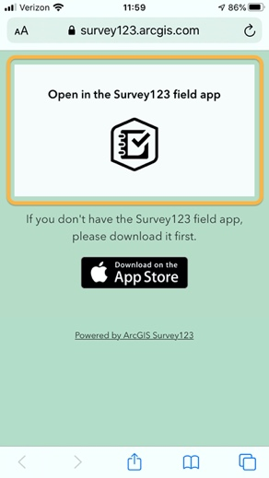
- Setup the iMap Survey Form
  - Once the Survey123 app has downloaded and installed, open a web browser on the device and go the following short URL:
https://arcg.is/vfeTW
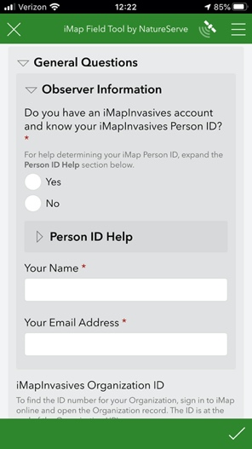
  - Once the page loads, tap the gray box titled:
Open in the Survey123 field app
(circled in orange, right).
Note, on iOS devices, this step may happen automatically.
  - The iMapInvasives Survey123 form will then download into the Survey123 app.
Once the survey form is visible (similar to the screenshot at right), it is downloaded and ready for use offline.

General iMap Survey123 Form Tutorial

- Complete the General Questions section, which includes information about the observer, date, and the state/province in which the record is being created.
- Create a Searched Area Polygon. (Ensure that the polygon is large enough to encapsulate and Presence and/or Treatment records which will also be associated with the record.)
- Complete any Searched Area Attribute Fields, as desired to describe the searched/surveyed area.
- Create Presence record(s).
  - Select the geometry type to represent the Presence – point, line, or polygon.
    - Use the Map icon 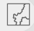 to create a line or polygon.
    - If representing the location as a Point, tap the Target icon to place a point at your current location.
  - Indicate the Present Species associated with the Presence record.
    - Start by entering the species. Search for a specific species by either scientific or common name using the auto-complete dropdown. (Note that the species list will be filtered to the tracked state/province list which was selected in the General Questions section.)
    - Complete any remaining fields representing the Present Species as desired.
    - Once your Present Species record is complete, you have two options:
      - Create an additional Present Species (to record additional species at this particular point/line/polygon location) using the first set of Delete (trash) or Add (plus sign) icons.
      - Create another Presence record (to create a new Presence point/line/polygon) using the second set of Delete (trash) or Add (plus sign) icons.
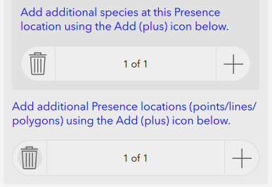
- Create Not Detected record(s)
  - To create a Not Detected record, select the plus icon within the Not Detected Records section.
  - There is no polygon to create, as the entire Searched Area polygon will represent the area in which the species was not detected.
  - Complete any other desired fields.
  - If needed, add additional Not Detected records using the Delete (trash) or Add (plus sign) icons within the Not Detected Records section.
- Create Treatment record(s)
  - Within the Treatments Applied section, add a new treatment record using the plus icon.
  - Create a polygon to represent the treated area.
    - To use the Searched Area polygon to represent the treatment area polygon, select Yes to the Use entire Searched Area for this Treatment record?
    - Otherwise, select the map icon to create a new polygon. (Note that the treatment polygon should fall within the Searched Area polygon.)
  - Complete the remaining treatment fields as desired. Note that certain fields will be displayed based on selections to other fields.
  - If needed, add additional Treatment records using the Delete (trash) or Add (plus sign) icons within the Treatments Applied section.
- Upload the record
  - Once the record is complete, click the Check icon at the bottom right of the survey form
    - The survey form will be validated for errors.
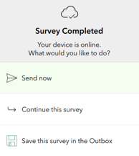
    - If connected to the internet and the form passes validation, it can either be uploaded immediately or saved to the Outbox (which queues records for later upload).
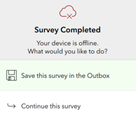
    - If offline, the validated record can only be saved to the Outbox.
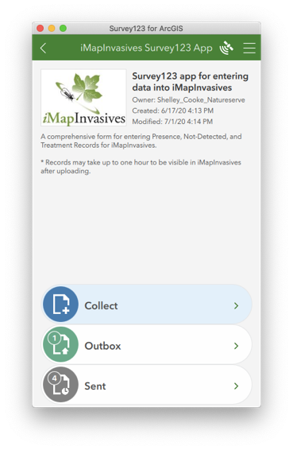
    - To upload records from the outbox:
Once connected to the internet, return to the main iMapInvasives Survey123 App menu and select the Outbox, where the records pending upload will be visible. To upload all records pending upload at once, select the Send button.
  - Note that it may take up to an hour for the record to be visible in the iMapInvasives online platform, and that all Presence records will be entered as “Unconfirmed.”

General Usage Tips

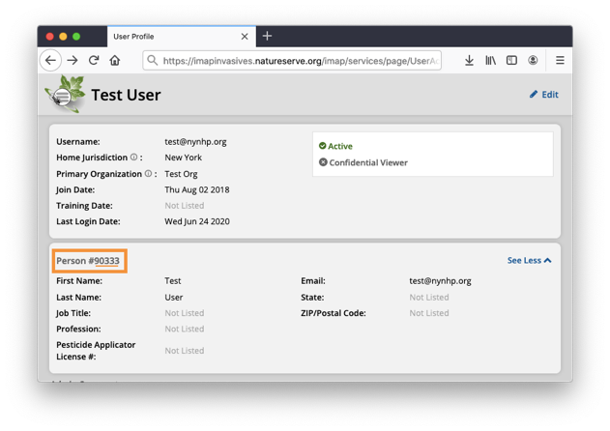
- If you have an iMapInvasives account, determine your Person ID before using the survey form.
To do so, sign-in to your account from a web browser:
https://imapinvasives.natureserve.org/imap/login.jsp
Then select the main menu at the top left and select My Account. Your Person ID will be visible on this page.
For example, in the screenshot (right), the Person ID is 90333.
- Create a Searched Area polygon that is large enough to contain the Presence, Not Detected, and Treatment areas.
- Once a Searched Area polygon is created, it can be utilized as the Presence polygon and/or Treatment polygon. See specific instructions above for more details.
- Treatment target species should have an intersecting Presence record for the same species. If you are not certain if a Presence record already exists in iMapInvasives for the treatment target species, please create an accompanying Presence record in Survey123.
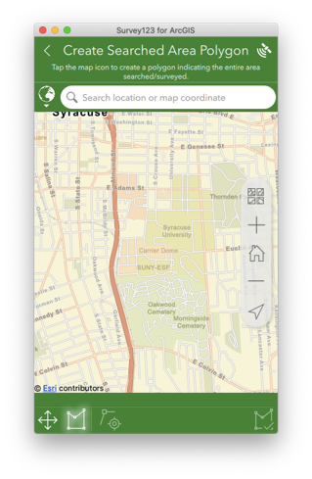
- Utilize GPS for polygon or polyline:
When creating a line or polygon, your current GPS location can be utilized to create a vertex at your current location. To do so, select the icon of a target accompanying a vertex (circled in orange in screenshot, right).
- Utilize the Favorite Answers feature after you have completed the General Questions section. Subsequent surveys can then have this information automatically copied into the fields captured by the “favorite answers” to help speed data collection. (Although be sure the correct state is selected when collecting data.)
For more information on using the Favorites feature, see the section of this Esri support document titled Favorite answers:
https://doc.arcgis.com/en/survey123/desktop/create-surveys/prepopulateanswers.htm

